Introduction to Spring Framework

- Spring is an open source framework created by Rod Johnson.
- Spring framework is used for developing Enterprise Applications in Java.
- By using Spring framework we can develop high performing, easily testable, reusable and loosely coupling Enterprise Applications in Java.

Features of Spring Framework

- Inversion of Control (IoC) container
- Supports Aspect Oriented Programming (AOP)
- Provides JDBC abstract layer to interact with database servers
- Provides integration with existing ORM frameworks like JPA, Hibernate, Ibatis etc
- Supports building MVC based web applications
- Provides integration with other web frameworks like Struts, JSF etc
- Provides services such as transaction management, scheduling, email etc

Spring Modules

- The Spring framework consists of 20+ modules.
- These modules are categorized into Core Container, Data Access/Integration, Web, AOP (Aspect Oriented Programming), Instrumentation and Test, as shown below:
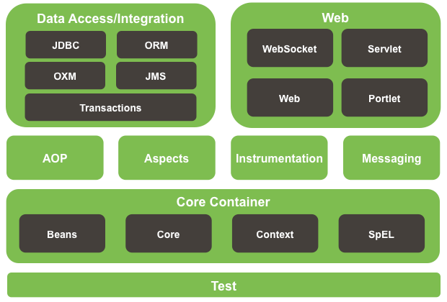
Core Container Module

- The Core container module is basis (foundation) for complete Spring framework.
- The Spring Core container provides implementation for IoC supporting Dependency Injection.
- The Spring Core container is responsible for managing objects lifecycle such as:
- Creating objects
- Calling initialization & destruction methods

Data Access/Integration Module

- The Data Access/Integration module consists of JDBC, ORM, OXM, JMS and Transaction modules:
- The JDBC module provides a JDBC abstraction layer interacts with database server.
- The ORM module provides integration with ORM frameworks such as JPA, Hibernate, Ibatis etc.
- The OXM module provides an abstraction layer that supports Object/XML mapping implementations for JAXB, Castor, XMLBeans, JiBX and XStream.
- The Java Messaging Service (JMS) module contains features for producing and consuming messages.
- The Transaction module supports programmatic and declarative Transaction Management.

AOP Module

- The AOP module provides Aspect Oriented Programming functionality in the Spring framework.
- This module supports defining method interceptors and point cuts to decouple (separate) cross cutting concerns such as logging, caching, transaction, security etc., from business logic of the application.
- The separate Aspects module provides integration with AspectJ.
Web Module
- The Web module consists of the Web, Servlet, WebSocket and Portlet modules.
- The Web module provides basic web oriented integration features such as multipart file upload functionality, initialization of IoC container using Servlet listeners and a web oriented application context.
- The Servlet module contains Model-View-Controller (MVC) implementation for web applications.
- The Portlet module provides the MVC implementation to be used in a portlet environment.

Test

- The Test module supports testing of Spring components/classes with JUnit or TestNG.
- It also provides mock objects that you can use to test your code in isolation.

Spring Framework Libraries

- Following are the steps to download the Spring framework jars on your machine:
- Download the latest version of Spring framework binaries from http://repo.spring.io/release/org/springframework/spring/
- For this tutorial, I downloaded spring-framework-4.0.6.RELEASE.zip and when you unzip the downloaded file, it will give you directory structure inside D:\spring-framework-4.0.6.RELEASE as follows:

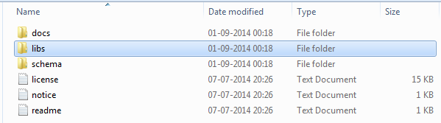
What’s New in Spring Framework 4.x

- The Spring Framework 4.0 supports Java 8 features. You can still use Spring with older versions of Java.
- The Spring Framework supports Java EE 6 and Java EE 7.

Inversion of Control (IoC) or Dependency Injection (DI)

- Inversion of Control is an architectural design pattern.
- Inversion of Control describes that a dependency injection needs to be done by an external entity (container) instead of creating the dependencies by the component itself.
- Dependency Injection is a process of injecting (pushing) the dependencies into an object.
- The benefit of Dependency Injection is to build loosely coupled applications.

Example to demonstrate a Loosely Coupled Application using Interface, Polymorphism & Factory Design Pattern

Solution [Shape.java]

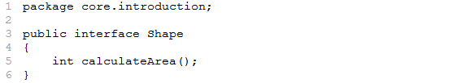

Solution [Square.java]

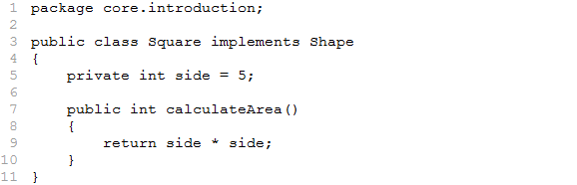

Solution [Rectangle.java]

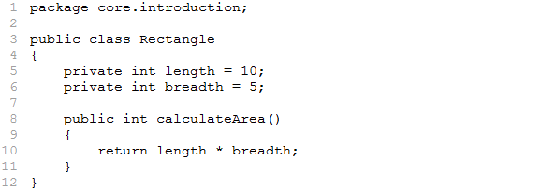

Solution [ShapeFactory.java]

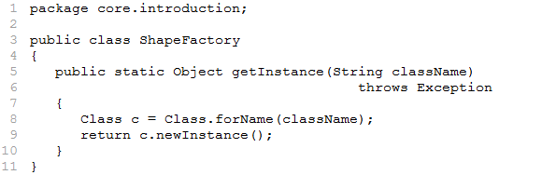

Solution [DrawingApp.java]

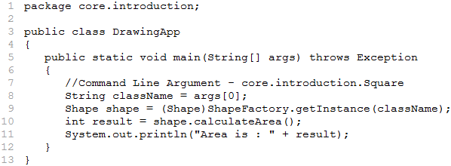
Spring Core Container

- The Core container is basis (foundation) for complete Spring framework.
- The Core container is responsible for creating the objects and managing their complete lifecycle from creation till destruction.
- The Core container uses IoC or Dependency Injection (DI).
- The following diagram is a high-level view of how Spring container works:

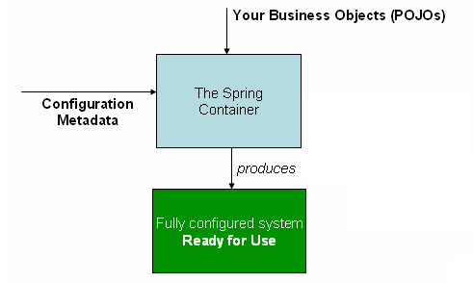

- The configuration metadata can be represented either by XML, Java Annotations, or Java code.

Initializing Spring Core Container

- The Spring Core container can be instantiated by creating an object of any one of the BeanFactory (or) ApplicationContext implementation classes by supplying configuration metadata.
- The Spring framework comes with 2 distinct types of containers:
- BeanFactory interface (org.springframework.beans.factory.BeanFactory)
- ApplicationContext interface (org.springframework.context.ApplicationContext)

ApplicationContext

- The ApplicationContext is a sub interface of BeanFactory interface.
- The ApplicationContext supports Internationalization (I18N) messages, validations, e-mail, JNDI access, EJB integration, scheduling etc.
- The mostly used implementations of ApplicationContext interface are:
- ClassPathXmlApplicationContext - Loads a context definition from an XML file located in the class path. This is used in standalone applications.
- FileSystemXmlApplicationContext - Loads a context definition from an XML file located in the file system. This is used in standalone applications.
- AnnotationConfigApplicationContext - Standalone application context, accepting annotated classes as input.
- XmlWebApplicationContext - Loads context definitions from an XML file. This is used in a web application.
- AnnotationConfigWebApplicationContext - Web application context, accepting annotated classes as input

Initializing Spring Core Container

- We can initialize the Spring Core container by using below constructors (mostly used):
- public ClassPathXmlApplicationContext(String configLocation)
throws BeansException
Creates a new ClassPathXmlApplicationContext by loading the definitions from the given XML file. The “configLocation” is name of XML file.
- public ClassPathXmlApplicationContext(String... configLocations)
throws BeansException
Creates a new ClassPathXmlApplicationContext by loading the definitions from the given XML files. In this case we can pass more than one XML file separated by a semi-colon.

Accessing Spring Beans
- We can use getBean() method of ApplicationContext to get the reference of the object created by Spring container.
- Object getBean(String name) throws BeansException
The getBean() method returns the reference of the object created by Spring container. The “name” is nothing but identifier of bean configured in XML file.

Example to demonstrate Instantiating Spring Container and accessing Spring Beans (using ClassPathXmlApplicationContext)

Solution [Shape.java]
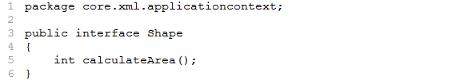

Solution [Square.java]
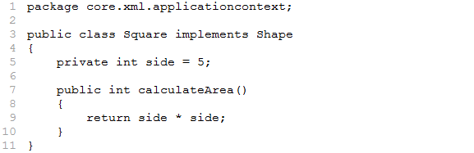

Solution [Rectangle.java]
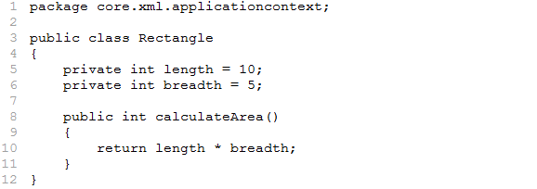
Solution [context.xml]
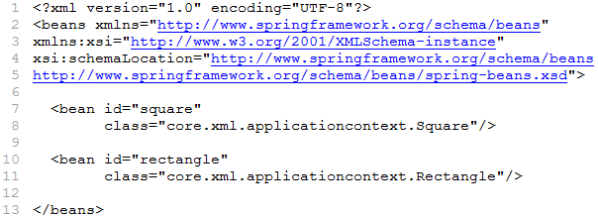

Solution [DrawingApp.java]
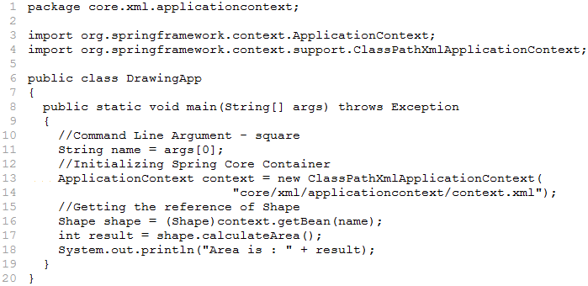

Note: We need below list of jars to execute all the examples on Core module using XML:

- spring-beans-4.0.6.RELEASE.jar
- spring-context-4.0.6.RELEASE.jar
- spring-core-4.0.6.RELEASE.jar
- spring-expression-4.0.6.RELEASE.jar
- commons-logging.jar
Configuring Beans

- Spring is a POJO based container framework.
- The Spring Core container is responsible for creating and managing the lifecycle of the Java beans.
- The developer has to provide information about beans and their dependencies in a configuration metadata to Core container.
- There are 3 ways to provide configuration metadata to the Core container:
- XML based: Simple and traditional XML format
- Annotation-based: Introduced in Spring 2.5
- Java-based: Introduced in Spring 3.0
- A typical Spring configuration XML file looks like below:
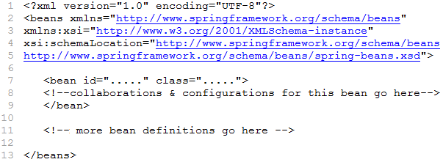

- This XML file begins with namespace declarations. In order to use elements like <beans>, <bean> etc., certain namespaces need to be declared.

<beans> Element

- The <beans> element is the root element of the Spring XML configuration file.
- This element encloses all the Spring bean definitions in XML file.
<bean> Element

- The <bean> element is the basic configuration in Spring XML file. It tells Core container to create an object for the Java bean.
Attributes of <bean> Element

class

- The class attribute of <bean> element defines the type of the bean. This attribute takes fully qualified class name as value.
- The class attribute is the only mandatory attribute in <bean> element.

id

- The id attribute is used to specify the bean identifier.
- The id attribute allows specifying exactly one id. This is the preferred way to specify a bean identifier.
- The XML specification limits the characters that are legal in XML id attribute.
name

- The name attribute is used to specify the bean identifiers.
- The name attribute can take more than one identifier. To specify the identifiers in name attribute, use comma [,], semicolon [;] or whitespace as separator. The extra identifiers are considered as aliases.
- The name attribute also accepts special characters in identifiers.

Note: It is not mandatory to supply a name or id for a bean. If no id or name is supplied explicitly, the container generates a unique identifier for that bean. The convention for naming beans is the standard Java naming convention.

<alias> Element

- The <alias> element is used to create additional name (alias) for identifiers defined using id or name attribute of <bean> element.
<alias name = “fromName” alias = “toName” />

In this case, a bean in the same container which is named “fromName” may also be referred to as “toName” after the configuration of this alias definition.

scope

- The beans configured in the Spring XML file are instantiated and managed by the Spring Core container.
- The Spring framework supports 6 bean scopes. We can use scope attribute of <bean> element to specify the bean scope.
- We can use the below values for scope attribute:

Scope | Description
singleton | Scopes a single bean definition to a single object instance per Core container. This is the default scope.
prototype | Scopes a single bean definition to any number of object instances. This means Spring produces a new bean instance each time one is needed.
request | Scopes a single bean definition to the lifecycle of a single HTTP request. Only valid in the context of a web-aware Spring ApplicationContext.
session | Scopes a single bean definition to the lifecycle of a HTTP Session. Only valid in the context of a web-aware Spring ApplicationContext.
globalSession | Scopes a single bean definition to the lifecycle of a global HTTP Session. Only valid when used in a portlet context and in the context of a web-aware Spring ApplicationContext.
application | Scopes a single bean definition to the lifecycle of a ServletContext. Only valid in the context of a web-aware Spring ApplicationContext.

lazy-init

- The ApplicationContext uses eagerly initialization strategy i.e., creates objects of singleton beans at startup of the Spring Core container.
- However, sometimes this behavior is not desirable and thus can be prevented by marking the bean definition as lazy-initialized.
- A lazy-initialized bean tells the container to create a bean instance when it is first requested (by calling getBean() method), rather than at startup.
- We can use lazy-init attribute of <bean> element for lazy initialization.
<bean id="square" class="com.pack.Square" lazy-init="true" />

- The lazy-initialization can also be applied to all the beans in XML file by using the default-lazy-init attribute on <beans> element.

Types of Dependency Injection

- If we use Spring container we need not provide the code for creating objects and setting up the dependencies, the Spring container takes care of this task. This is called as “Inversion of Control”.
- This is why Spring container is called as “IoC Container”.
- There are 3 types of Dependency Injection:
- Constructor Injection
- Setter Injection
- Interface Injection

Note: Spring supports constructor and setter injection and indirectly supports interface injection by using auto wire feature.

Constructor Injection:

- Injecting the dependencies of an object through its constructor argument(s) is known as Constructor Injection.
- In this approach the dependencies are pushed into the object through the constructor arguments at the time of instantiating (creating) it.

<constructor-arg> element

- The <constructor-arg> element describes one argument of the constructor. To specify a constructor with multiple arguments, we need to use the <constructor-arg> element multiple times.
- Following are the attributes of <constructor-arg> element:
Attribute | Description | Occurrence
type | This attribute takes the type of the constructor argument. The container uses type matching. | optional
index | This attribute takes the exact index in the constructor argument list. This is used to avoid ambiguities in case of two arguments being of the same type. The index is 0 based. | optional
value | This attribute takes a String or primitive data types as value. | optional
ref | This attribute takes the identifier of referenced data types as value. | optional

Note: If no <constructor-arg> elements are specified, then the default constructor is used.

Example to demonstrate Constructor Injection

Solution [Shape.java]
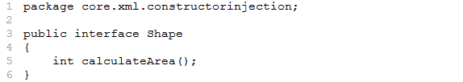

Solution [Square.java]
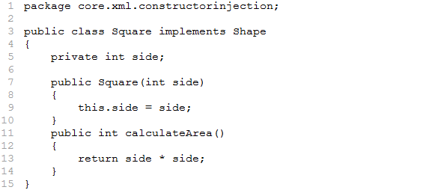

Solution [Rectangle.java]

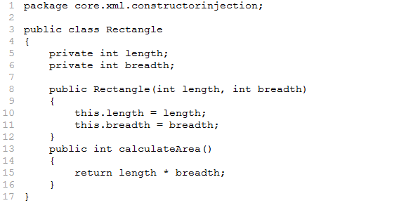
Solution [context.xml]
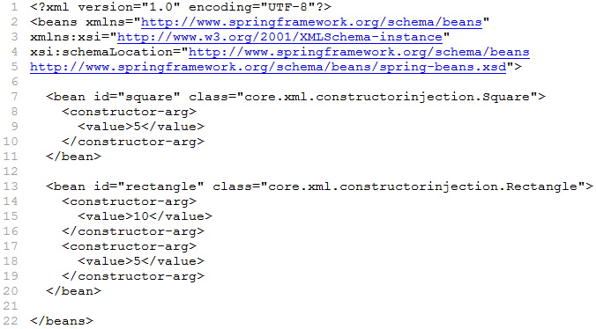

Solution [DrawingApp.java]
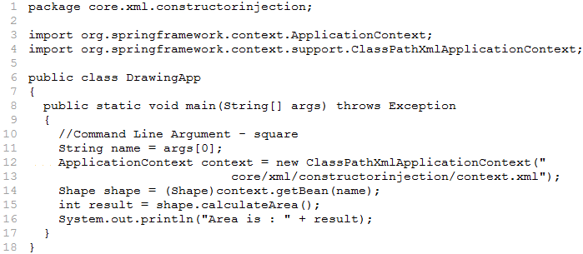
Assume the Customer bean with 2 argument constructor as shown below:

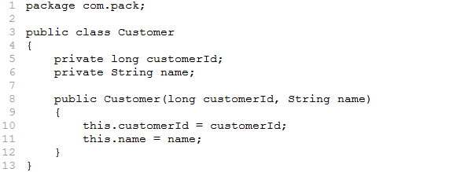

Configuration for Constructor Injection – type attribute
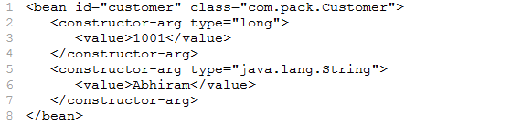

Configuration for Constructor Injection – index attribute
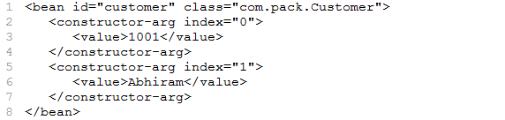

Configuration for Constructor Injection – name attribute
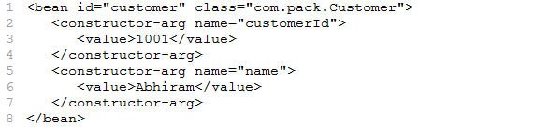

Setter Injection

- Injecting the dependencies of an object by using the setter method is known as Setter Injection.
<property> Element

- The <property> element is used to describe one setter method of the property which allows only one argument.
- The attribute of <property> element:
Attribute | Description | Occurrence
name | This attribute takes the name of the Java bean property i.e., this follows Java bean conventions like name of property “message” corresponds to setMessage() method. | required
value | This attribute takes a String or primitive data types as value. | optional
ref | This attribute takes the identifier of referenced data types as value. | optional

Example to demonstrate Setter Injection

Solution [Shape.java]
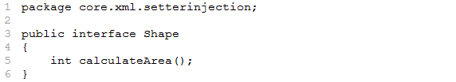

Solution [Square.java]
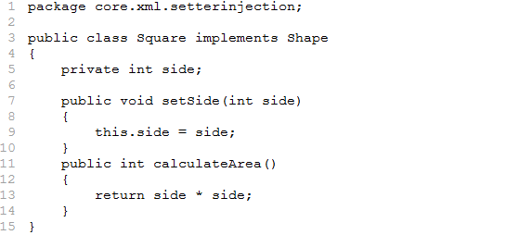

Solution [Rectangle.java]
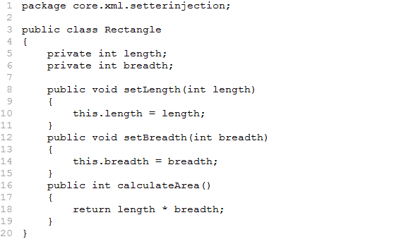

Solution [context.xml]
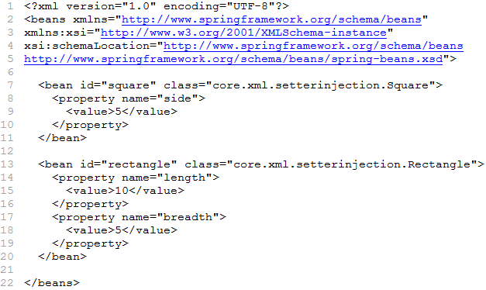

Solution [DrawingApp.java]
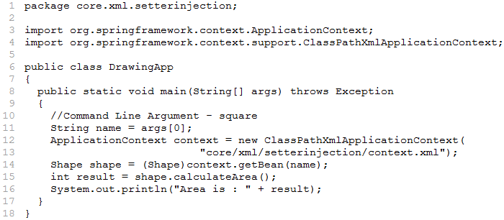

<value> Element

- The <value> element takes property value of a Java bean. This element can be placed either inside <constructor-arg> or <property> element.
- The <value> element takes String and primitive data types as values.
- We can also use value attribute of <constructor-arg> or <property> element to provide values.
Using <value> element inside <property> Element
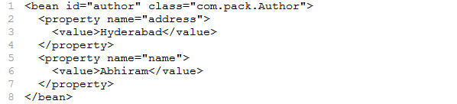
Using value attribute of <property> element
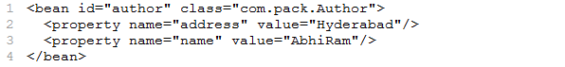
<ref> Element

- The <ref> element is used for injecting references. It can be placed either inside <constructor-arg> or <property> element.
- In reference injection, one bean definition is injected to another bean.
- We can also use ref attribute of <constructor-arg> or <property> element for injecting references.
Using <ref> element inside <property> element
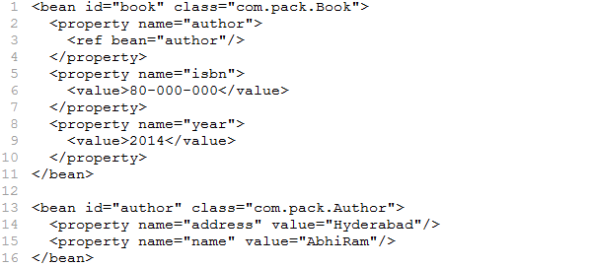

Using ref attribute of <property> element
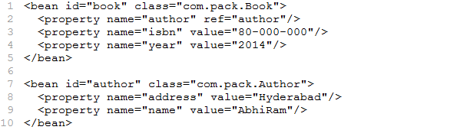
Example to demonstrate reference injection (constructor)

Solution [Author.java]
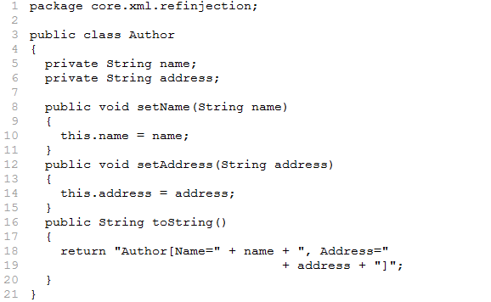

Solution [Book.java]
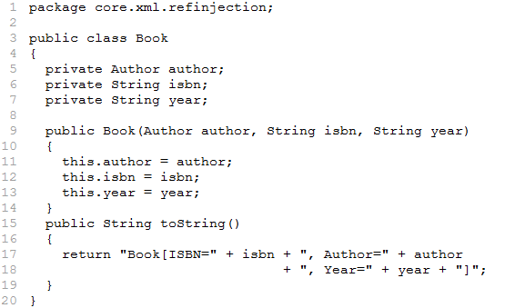

Solution [context.xml]
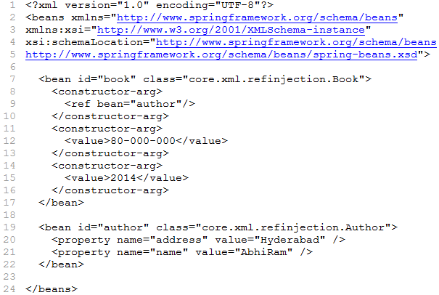

Solution [Test.java]
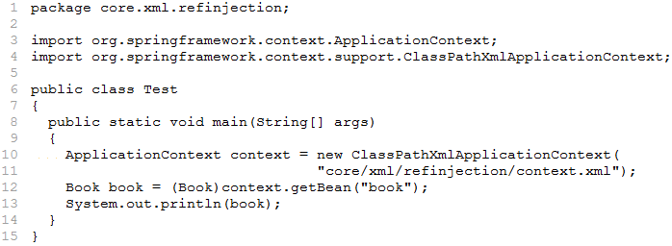

Inner beans

- An inner bean is defined by declaring <bean> definition directly as a child of <property> or <constructor-arg> to which it is injected.
- An inner bean definition does not require id or name.
Inner bean definition in <constructor-arg> element

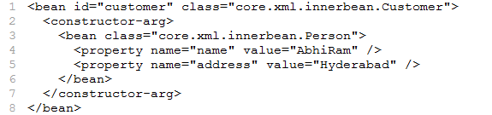

Inner bean definition in <property> element

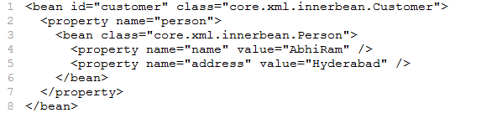

Injecting Collections

- So far we have learned how to configure primitive data types using value attribute and object references using ref attribute of the <constructor-arg> or <property> element in XML configuration file.
- Now we want to inject Java Collection types List, Set, Map, and Properties.
- Spring offers four types of collection configuration elements:
Element | Description
<list> | Used to inject a list of values (allowing duplicates)
<set> | Used to inject a set of values but without any duplicates
<map> | Used to inject a Map (key-value pair)
<props> | Used to inject a java.util.Properties object

Injecting Lists

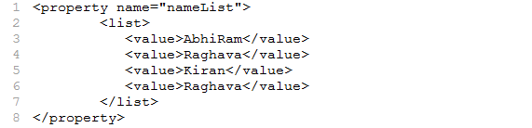

Injecting Sets

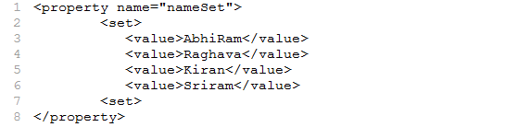

Injecting Maps

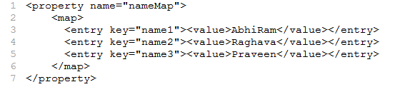

Injecting Properties

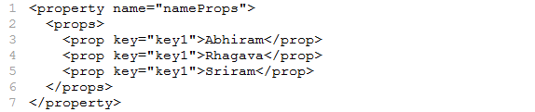

Note: In above examples, collection objects are injected to setters, we can inject collection objects to constructors as well.
Injecting empty String values

- If you need to pass an empty string as a value then you can pass it as follows:

<bean id="customer" class="com.pack.Customer">
<property name="name" value="" />
</bean>

The equivalent Java code for above example is customer.setName("");

Injecting NULL values

- If you need to pass a NULL as a value then you can pass it as follows:

<bean id="customer" class="core.pack.Customer">
<property name="name"> <null/> <property/>
</bean>

The equivalent Java code for above example is customer.setName(null);

Instantiating Bean using Static Factory Method

- The Spring Core container will create an object for a bean using default constructor or parameterized constructor (using <constructor-arg> element) based on configurations in XML file.
- We can also specify static factory method in XML file so that Spring container will use that static method to create an object to a bean.
- The factory method name can be specified by using the factory-method attribute of <bean> element.
Example to demonstrate Instantiating Bean using Static Factory Method

Solution [HelloService.java]
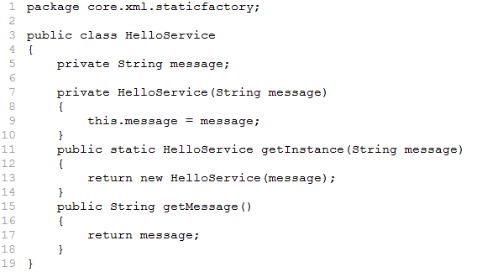

Solution [context.xml]
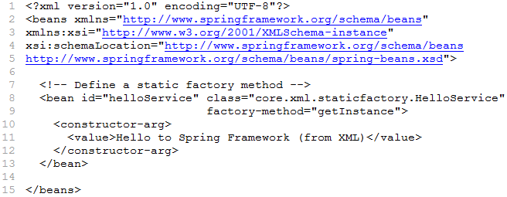

Solution [HelloServiceTest.java]
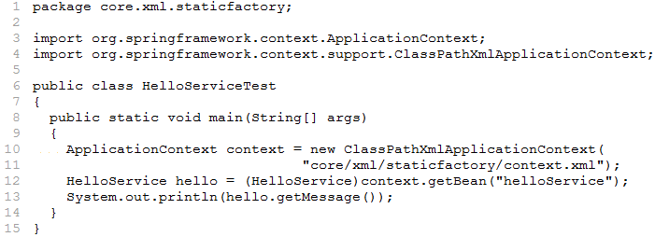
Spring Bean Life Cycle

- When a bean is instantiated, it may be required to perform some initialization task to get it into a usable state.
- Similarly, when the bean is no longer required and is removed from the container, some cleanup task may be required.

Initialization Callbacks

- For initialization lifecycle event, we need to implement afterPropertiesSet() method of org.springframework.beans.factory.InitializingBean interface. The signature of method is shown below:
public void afterPropertiesSet() throws Exception
- We need to provide initialization logic in afterPropertiesSet() method. This method is invoked by Spring container immediately after the bean is instantiated and setter methods.

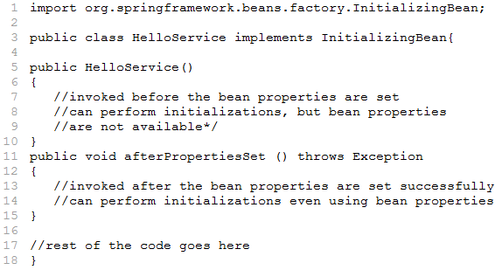

- The use of InitializationBean interface can be avoided by defining the initialization method name in the XML configuration file by using the init-method attribute of <bean> element.
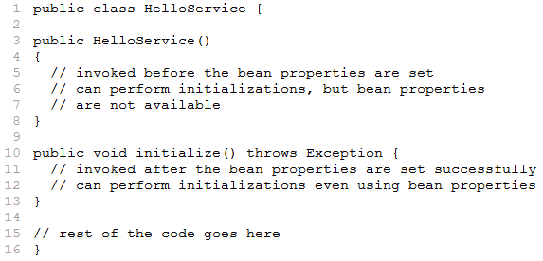

<bean id="service" class="core.xml.HelloService" init-method="initialize" />

Destruction Callbacks

- For destruction lifecycle event, we need to implement destroy() method of org.springframework.beans.factory.DisposableBean interface. The signature of destroy() method is shown below:
public void destroy() throws Exception
- We need to provide clean-up logic in destroy() method. This method is invoked by the Spring container just before it decides to put the bean out of service.

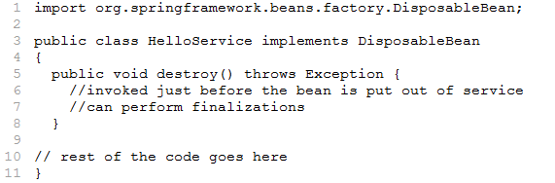

- The use of DisposableBean interface can be avoided by defining the destruction method name in the XML configuration file by using the destroy-method attribute of <bean> element.
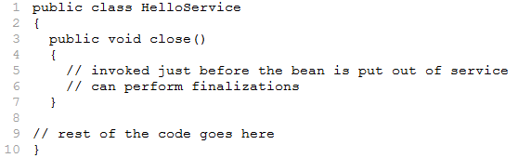

<bean id="service" class="core.xml.HelloService" destroy-method="close" />

Note: It is recommended to do not use the InitializingBean or DisposableBean callbacks, because XML configuration gives much flexibility in terms of naming your method.

Default initialization and destroy methods

- If you have too many beans having initialization and or destroy methods with the same method name, you don't need to declare init-method and destroy-method on each individual bean.
- Instead framework provides the flexibility to configure such situation using default-init-method and default-destroy-method attributes on the <beans> element as follows:

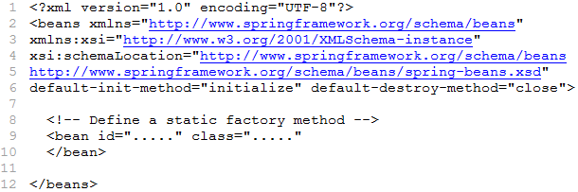
Wiring

- The act of creating associations (relations) between components in an application is referred to as wiring i.e. setting up the dependencies between the objects is called as wiring.

Auto Wiring:

- Spring container is able to setup the dependencies between objects even if the information about the dependencies is not provided in Spring XML file. This is called auto wiring in Spring.
- For using auto wiring feature we must use the autowire attribute of <bean> element as shown below:
<bean id="helloService" class="core.xml.HelloService" autowire="autowire-type" />
- The autowire-type attribute takes the following 4 values:

Mode | Description
no | This is the default mode, which means no auto wiring and you should provide explicit bean reference for wiring.
byName | Tries to match and wire its properties with the beans defined by the same names in the configuration file.
byType | Tries to match and wire its properties with the beans defined by the same data type in configuration file. If more than one such bean is available then an exception is thrown.
constructor | This is similar to byType, but applies to constructor arguments.
Example to demonstrate no auto wiring mode (default mode). Bean references must be defined via a ref element at the property/constructor.

Solution [Book.java]
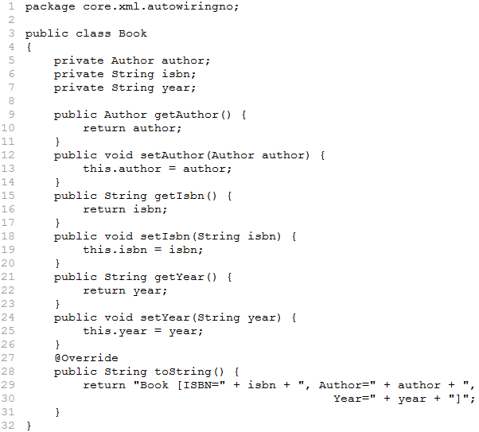

Solution [Author.java]
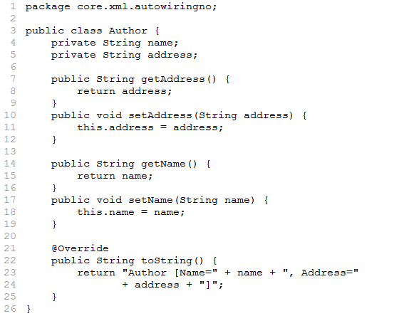

Solution [context.xml]
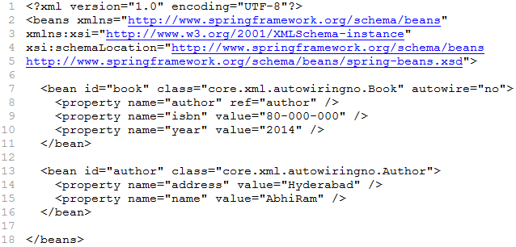
Solution [Test.java]
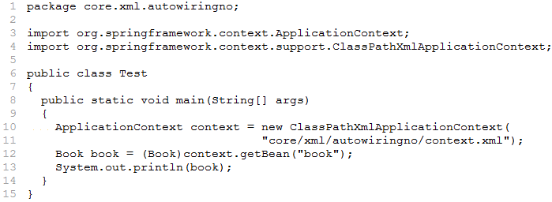

Example to demonstrate byName auto wiring mode

Solution [Book.java]
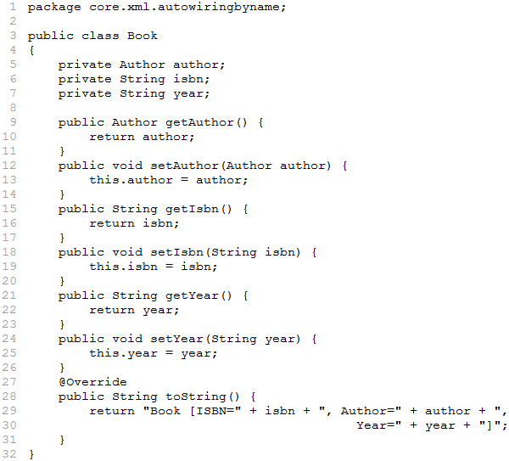

Solution [Author.java]
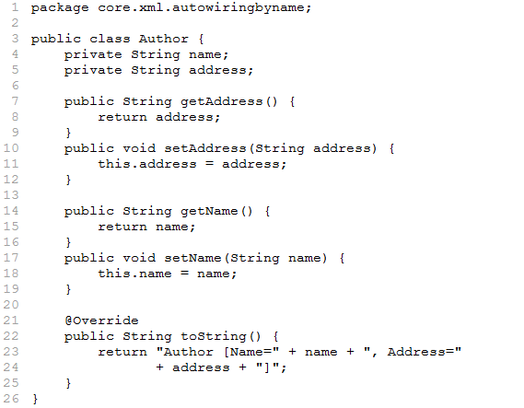

Solution [context.xml]
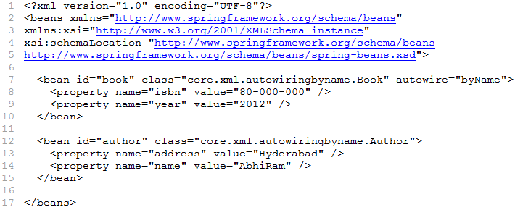

Solution [Test.java]
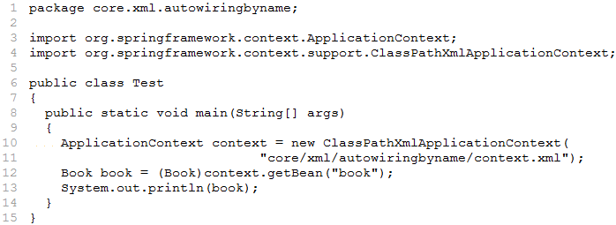

Example to demonstrate byType auto wiring mode

Solution [Book.java]
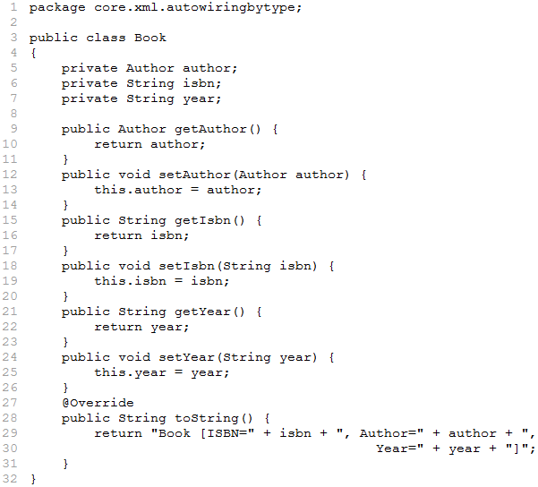

Solution [Author.java]
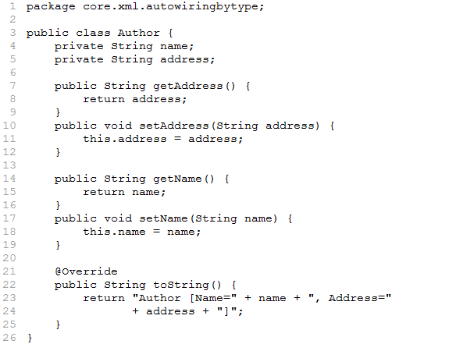

Solution [context.xml]
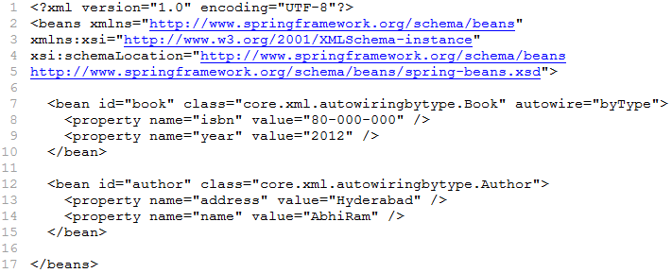

Solution [Test.java]
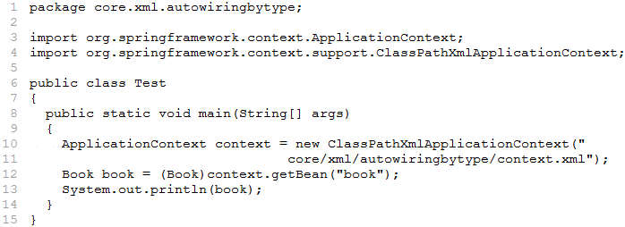

Example to demonstrate constructor auto wiring mode

Solution [Book.java]
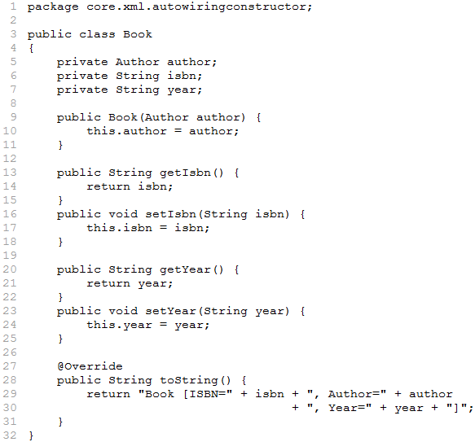

Solution [Author.java]
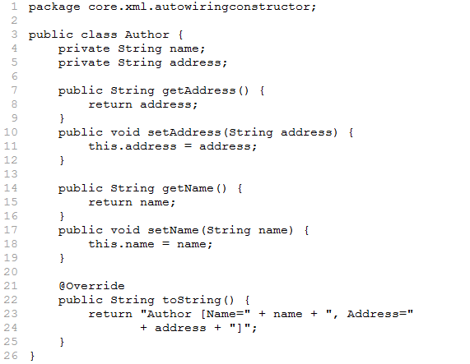

Solution [context.xml]
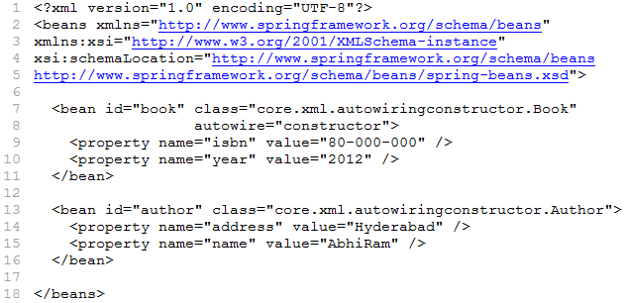

Solution [Test.java]
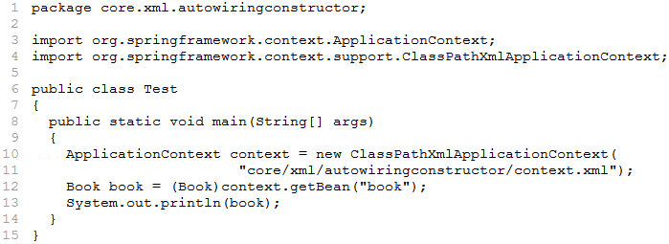

p-namespace

- p-namespace is used to describe the property values or referencing beans of a <bean> element.
- p-namespace can be used instead of <property> element which simplifies configurations.
- The following example shows using p-namespace instead of the <property> element:

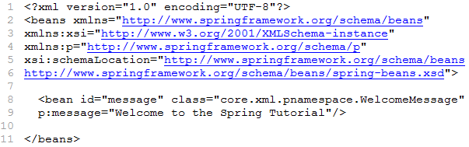

c-namespace

- Similar to the p-namespace, the c-namespace is used to describe the constructor arguments instead of <constructor-arg> element.
- The following example shows using c-namespace instead of the <constructor-arg> element:

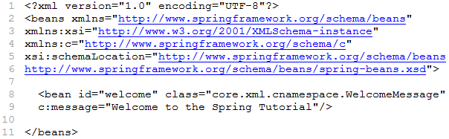
PropertyPlaceholderConfigurer

- The PropertyPlaceholderConfigurer class is used to load properties from an external property file. Configure the class in XML file as shown below:
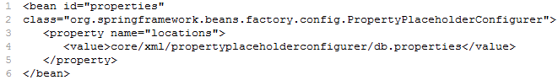

- The location property tells Spring container where to find the property file. In this case, the “db.properties” file contains the following database properties:

- Now you are able to replace the hard-coded configuration in XML file with placeholder variables. Syntactically, the placeholder variables take the form ${variable}, resembling Java Server Pages (JSP) expression language.

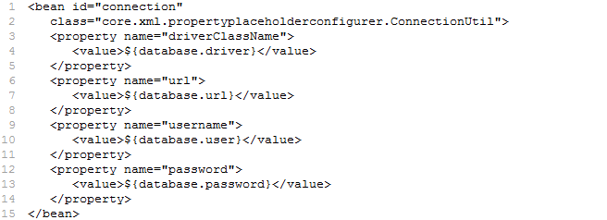

- The placeholder variables will be replaced with properties from “db.properties” when the Spring context is loaded.
Resolving Messages

- ResourceBundleMessageSource class is used to resolve text messages from properties file, based on the locale.

Example to demonstrate reading messages from properties file

Solution [message.properties]

Solution [context.xml]
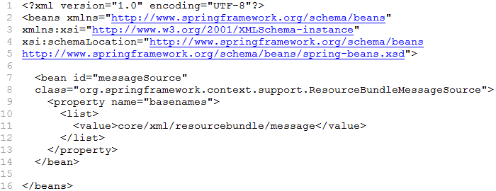

Solution [Test.java]
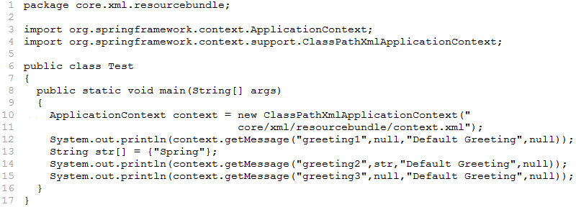
Configuring Beans Using Annotations

- Annotations are a powerful feature of Java, included in JDK 1.5 with the main objective to make the development easier.
- Annotations are like metadata which can be applied to variables, parameters, fields type declarations, methods and constructors.

Annotations in Spring

- Spring framework provides annotation-based configuration as an alternative to XML.
- In Annotation-based configuration, the configuration is moved into the component class itself by using annotations on the relevant class, method or field declaration.
- Spring framework provides 2 types of annotations.
- Auto Wiring: Spring automatically figures out how to wire bean dependencies
- Auto Scanning: Spring automatically figures out which classes should be configured as Spring beans.
Note: Annotation injection is performed before XML injection, thus the later configuration overrides the former for properties wired through both approaches.

Auto Wiring using Annotations

- By default, Annotation wiring is not turned on. It needs to be switched on in the Spring configuration XML file, before using annotation-based auto wiring.
- The <context:annotation-config> element from Spring’s context configuration namespace informs Spring that this application uses annotation-based wiring.

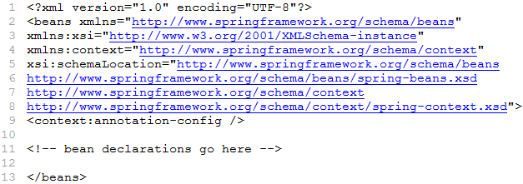

@Autowired Annotation

- The @Autowired annotation is very similar to autowire attribute of <bean> element in XML file.
- The @Autowired annotation can be used on a property or setter method or constructor.
- The required attribute of @Autowired annotation takes boolean value. This attribute is used for dependency checking.

Note: We need below list of jars to execute all the examples on Core module using Annotations:

- spring-aop-4.0.6.RELEASE.jar
- spring-beans-4.0.6.RELEASE.jar
- spring-context-4.0.6.RELEASE.jar
- spring-core-4.0.6.RELEASE.jar
- spring-expression-4.0.6.RELEASE.jar
- commons-logging.jar

Example to demonstrate @Autowired annotation on Setter method

Solution [Book.java]
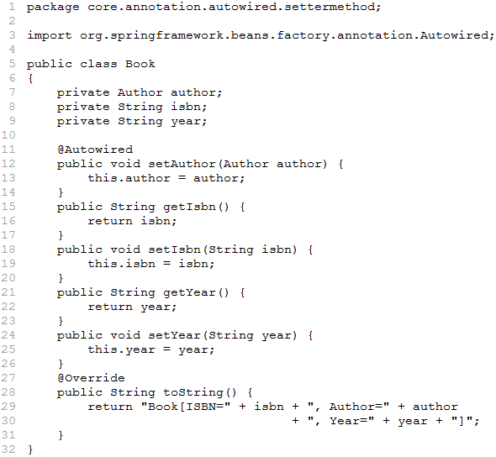
Solution [Author.java]
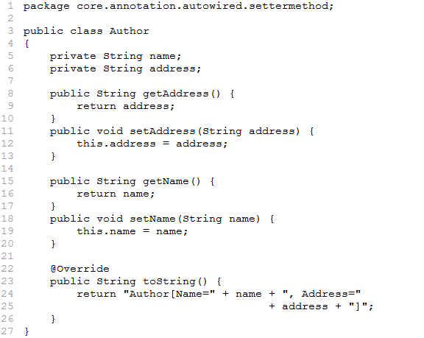

solution [context.xml]
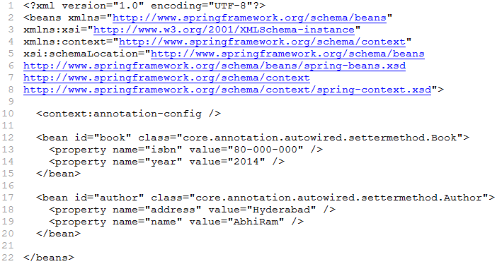

Solution [Test.java]
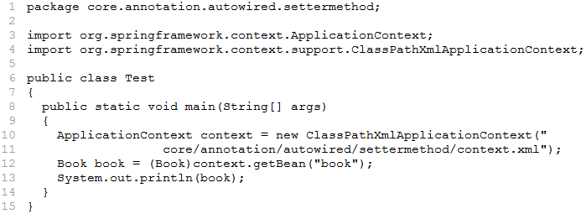

Example to demonstrate @Autowired annotation on Constructor

Solution [Book.java]
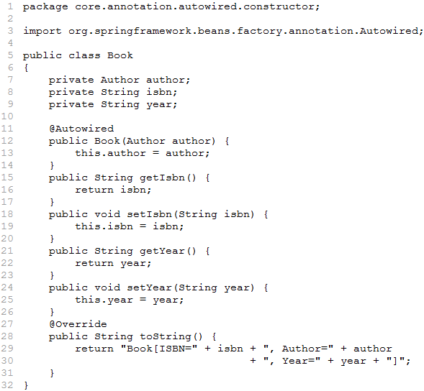

Solution [Author.java]
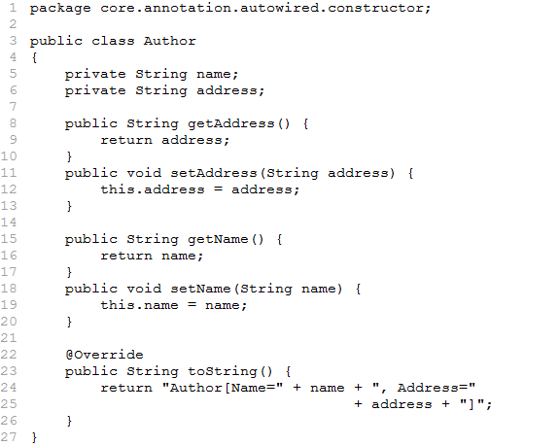

Solution [context.xml]
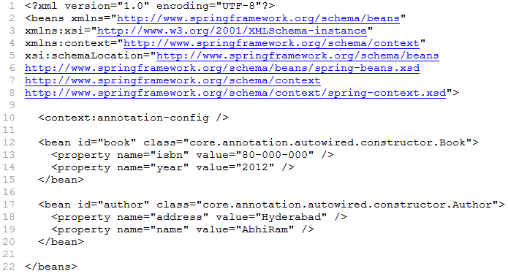

Solution [Test.java]
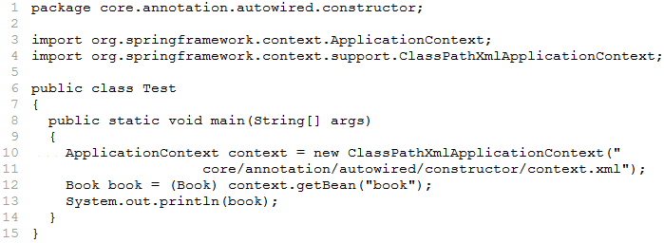

Example to demonstrate @Autowired annotation on Property

Solution [Book.java]
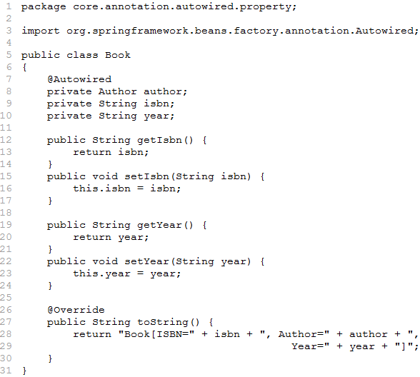

Solution [Author.java]
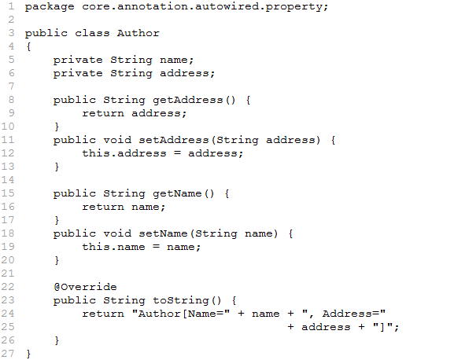

Solution [context.xml]
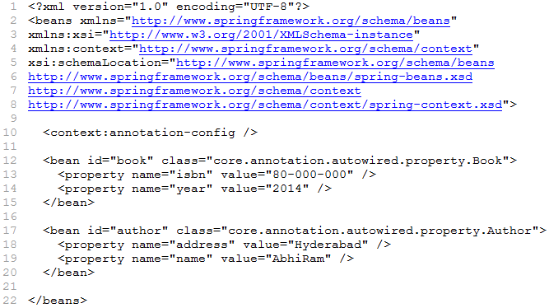

Solution [Test.java]
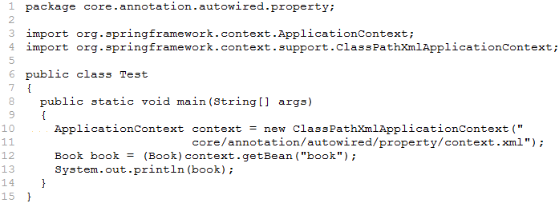

Dependency Checking

- By default, the @Autowired annotation perform dependency checking to make sure the property has been wired properly.
- When Spring cannot find a matching bean to wire, it throws an exception. At times, this is not an acceptable behavior, as the property on which it fails may be optional. In such scenarios, the dependency checking can be disabled by setting the required attribute of @Autowired to false.
- When the required attribute of @Autowired is set to false, Spring tries to wire the property. But if no bean of that type can be found, then the property is left null.

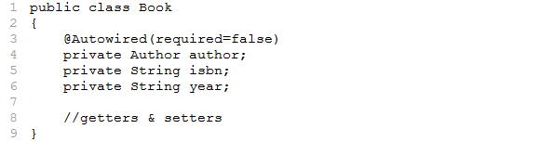
@Qualifier Annotation

- Sometimes, it may happen that there are two or more beans, each of which equally qualifies to be wired into a property or a constructor argument. In such scenario, Spring does not decide which one is the right one, instead it may throw a NoSuchBeanDefinitionException.
- The @Qualifier annotation can be used to decide which bean should be auto wired. This annotation can be used on a property or individual constructor arguments or method parameters.
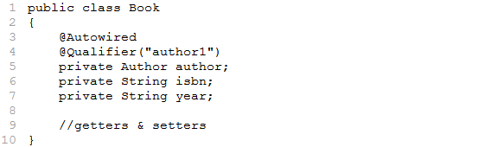

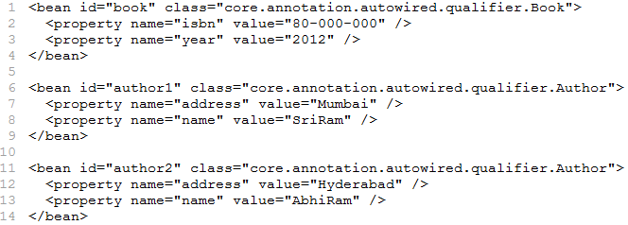
Auto Scanning using Annotations

- Beans or components are configured in the XML file. The Spring container knows about the beans or components information from XML file.
- The Spring frame work is also capable of automatically scanning, detecting and instantiating the beans from pre-defined packages (sub packages).

Switching on Auto Scanning

- The <context:component-scan> informs Spring to automatically detects and instantiate the beans. This means the beans in the Spring application can be declared and wired without using <bean> element.
Note: <context:component-scan> does everything that <context:annotation-config> does, in addition to auto scanning.
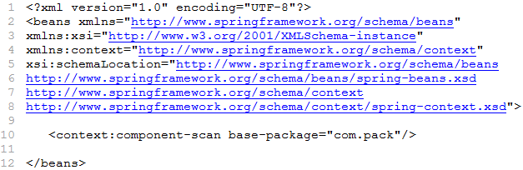

- The <context:component-scan> scans a package and all of its sub packages, looking for classes that could be automatically registered as beans in the Spring container.
- The <context:component-scan> looks for classes that are annotated with one of the following annotations:
- @Component: Indicates that the class defines a Spring Component
- @Controller: Indicates that the class defines a Spring MVC Controller
- @Repository: Indicates that the class defines a Data Repository
- @Service: Indicates that the class defines a Service
Example to demonstrate @Component Annotation

Solution [MessageDAO.java]
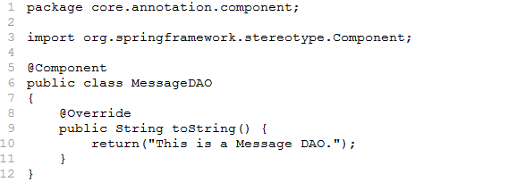

Solution [MessageService.java]
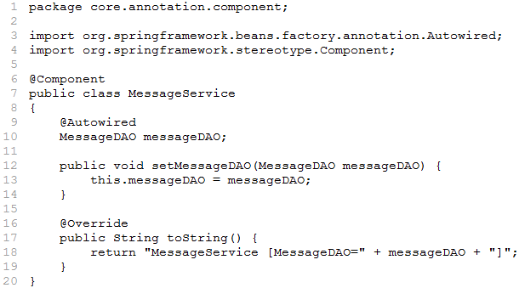

Solution [context.xml]
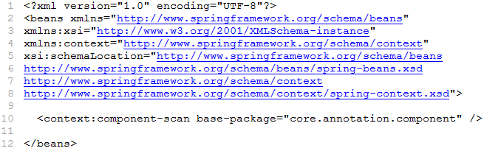

Solution [Test.java]
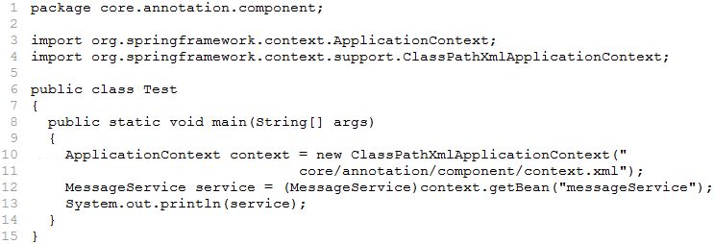

Note: By default, the ID of the bean is generated by camel-casing the class name. So MessageDAO’s bean ID will be messageDAO.
@Scope

- @Scope annotation works similar to scope attribute in <bean> element in XML file. The value attribute of @Scope annotation is used specify type of the scope.

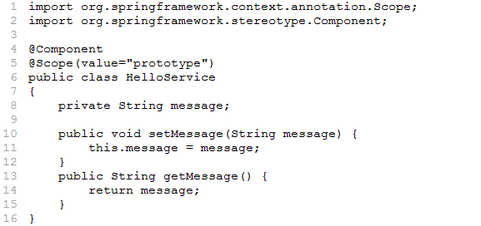

@PostConstruct and @PreDestroy
- @PostConstruct and @PreDestroy annotations work similar to the init-method and destroy-method in the bean configuration file.
- Use @PostConstruct annotation on top of initialization method. This method is invoked by Spring once the bean is instantiated and setters are executed.
- Use @PreDestroy annotation on top of destruction method. This method is invoked by Spring once the bean is removed from service.
Example to demonstrate @PostConstruct and @PreDestroy Annotations

Solution [MessageService.java]
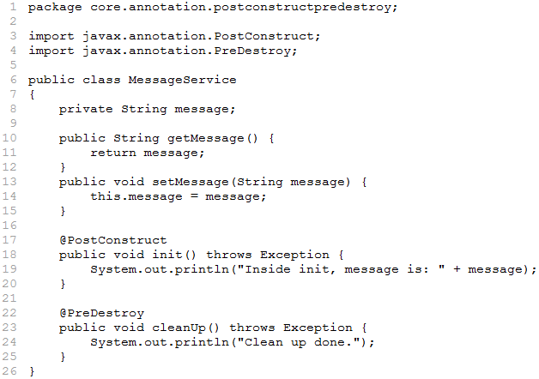

Solution [context.xml]
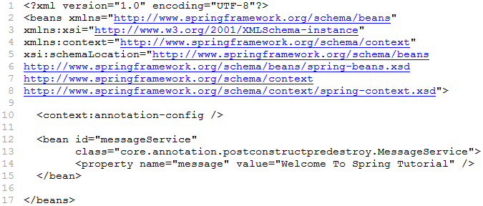

Solution [Test.java]
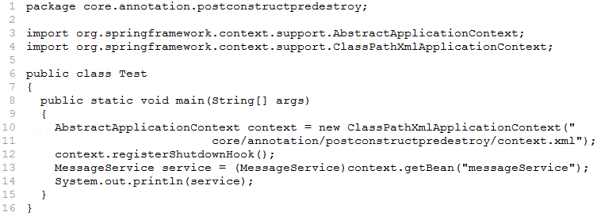

Configuring Beans using Java Configuration

- A Spring application can be configured with almost no XML file by using pure Java configurations. In case of Java based configuration we can configure all beans in Java class.

Defining a Java based Configuration Class

- To tell Spring about the beans in the application, all beans which were written in the Spring XML file will now be written in form of a Java class annotated with @Configuration as shown below:

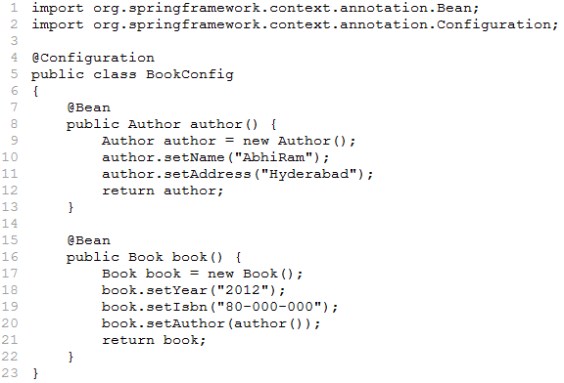

Explanation:

- @Configuration: Is placed above the class, it tells Spring container that this is a configuration class having bean definitions and dependencies. This is equivalent to <beans> in XML file.
- @Bean: Is used to define a bean. This is equivalent to <bean> in XML file.

Example to demonstrate Java based Configuration

Solution [Book.java]
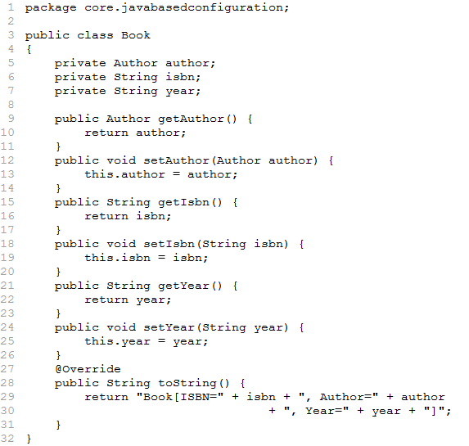

Solution [Author.java]
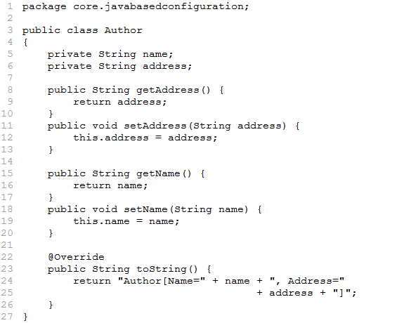

Solution [BookConfig.java]
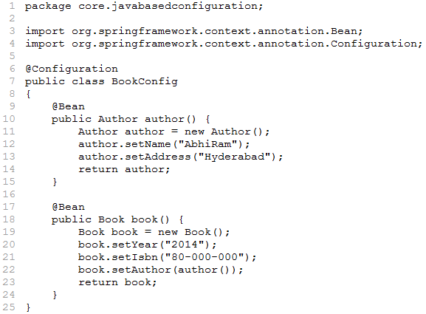

Solution [Test.java]
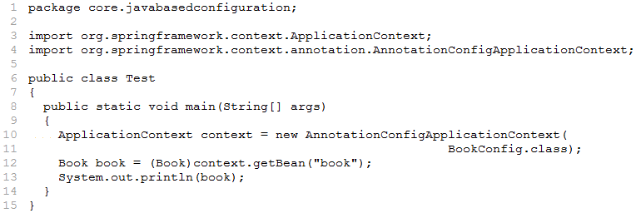

Explanation:

- The beans are defined programmatically as part of the Java based configuration. The BookConfig class represents configuration class just like the XML. This is achieved using @Configuration annotation.
- The @Configuration annotation is placed above the class. It tells the Spring container that this is a configuration class having bean definitions and dependencies.
- The @Bean annotation is used to define the bean. This annotation is placed above the method that instantiates the bean and sets the dependency. The method name is same as bean id or name by default. The return type of the method is the bean that is registered in Spring application context.
- The author() and book() methods creates and returns the instance of Author and Book beans. These objects are registered in the Spring application context.

Loading Configuration class using AnnotationConfigApplicationContext

- The AnnotationConfigApplicationContext class is used for a Java based configurations.

- The AnnotationConfigApplicationContext class is one of the implementation classes of ApplicationContext interface.

Example to demonstrate passing values to Constructor

Solution [Book.java]
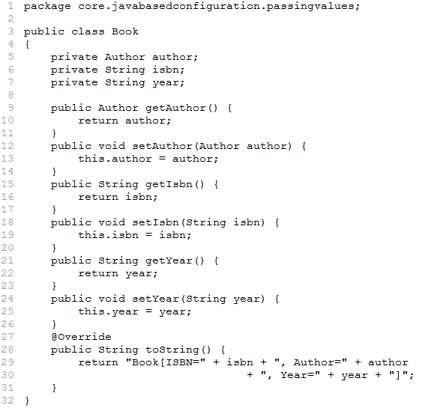

Solution [Author.java]
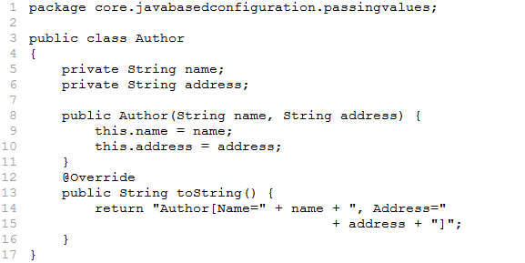

Solution [BookConfig.java]
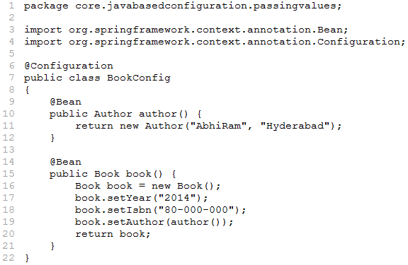

Solution [Test.java]
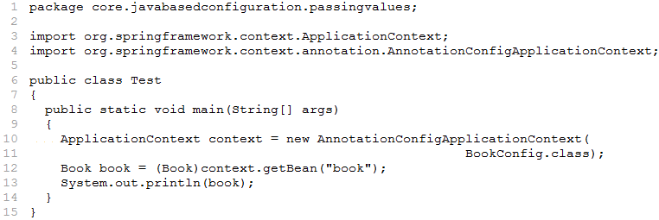

Example to demonstrate Bean Lifecycle Callbacks

Solution [Customer.java]
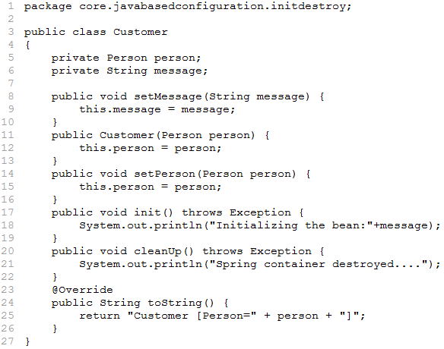

Solution [Person.java]
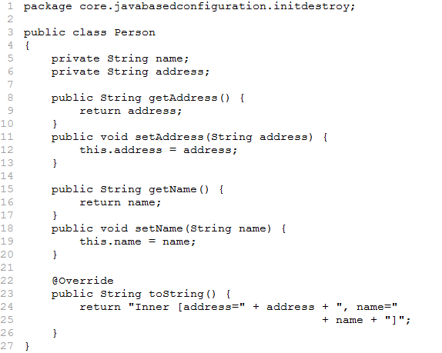

Solution [AppConfig.java]
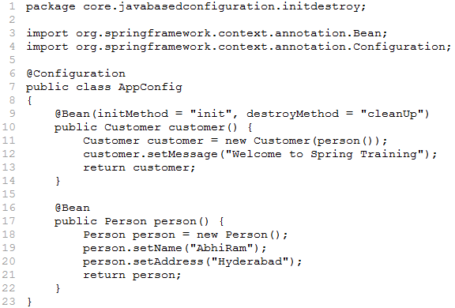

Solution [Test.java]
